DSA Fundamentals in Java: Arrays, Stacks, Queues (with Labs & Code)
Data Structures and Algorithms (DSA) are fundamental to writing efficient software.
This tutorial covers three core structures used heavily in algorithms, interviews, and systems:
- Arrays
- Stacks
- Queues
You’ll also find real Java code examples and lab exercises.

1. Arrays
An array is a fixed-size collection of elements of the same data type stored in contiguous memory locations.
Example:
Index: 0 1 2 3 4
Value: 10 20 30 40 50

Array Memory Layout

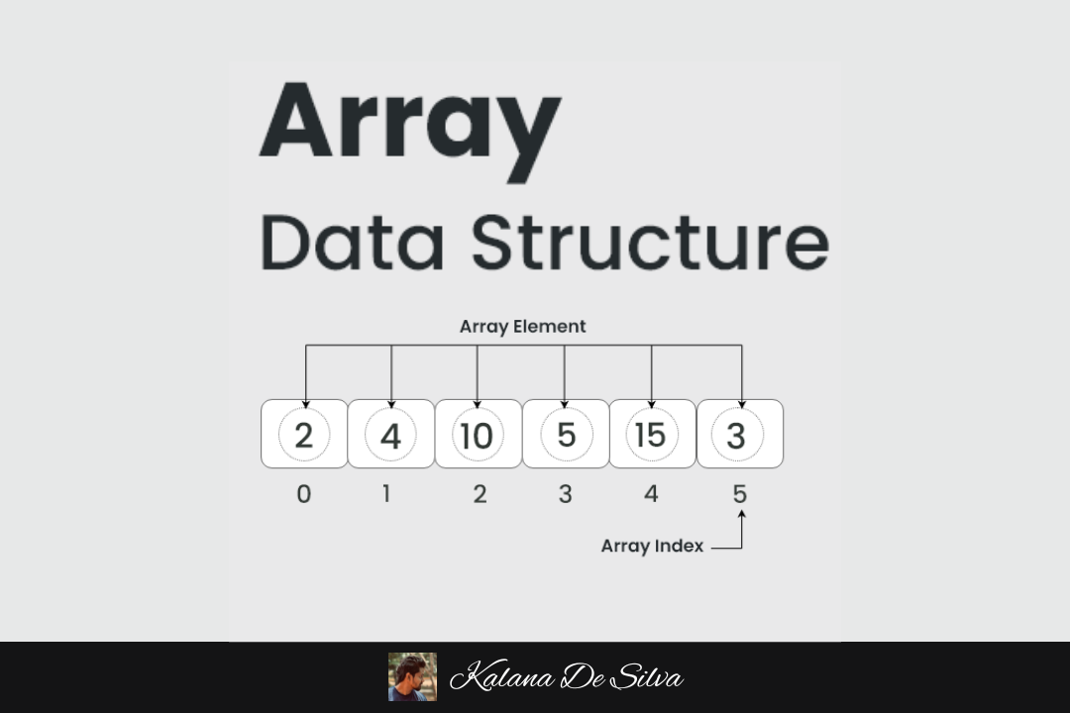
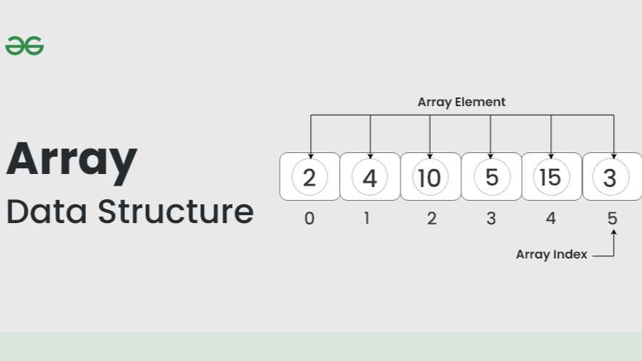
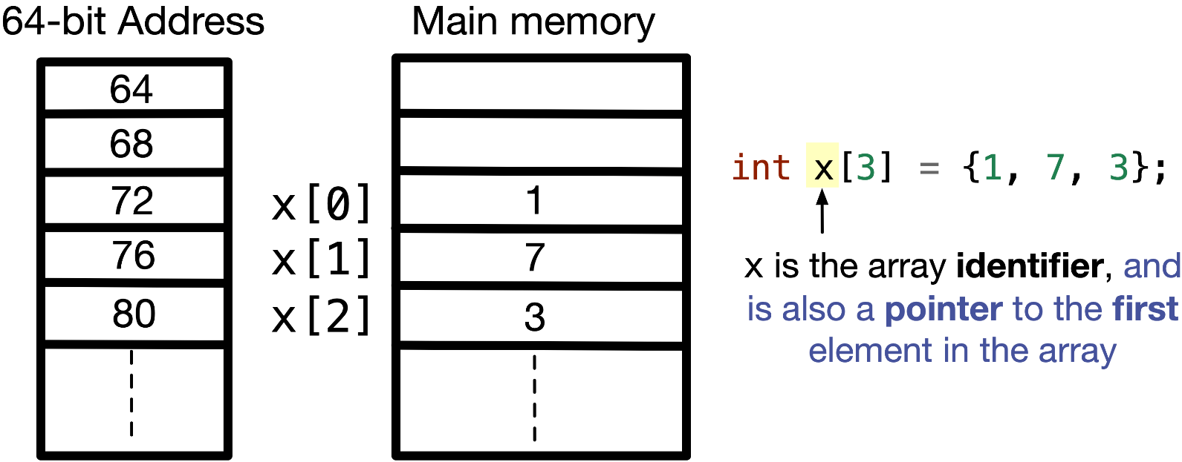

Creating an Array in Java
public class ArrayExample {

public static void main(String[] args) {

int[] numbers = {10,20,30,40,50};

System.out.println(numbers[2]);
}
}
Output:
30

Traversing an Array
public class ArrayTraversal {

public static void main(String[] args) {

int[] arr = {10,20,30,40,50};

for(int i=0;i<arr.length;i++){
System.out.println(arr[i]);
}
}
}

Insert Element in Array
public class InsertArray {

public static void main(String[] args) {

int[] arr = new int[6];

arr[0]=10;
arr[1]=20;
arr[2]=30;
arr[3]=40;
arr[4]=50;

int position=2;
int value=25;

for(int i=4;i>=position;i--){
arr[i+1]=arr[i];
}

arr[position]=value;

for(int n:arr){
System.out.println(n);
}
}
}

Search Element in Array

Linear Search
public class LinearSearch {

public static void main(String[] args) {

int[] arr={10,20,30,40,50};
int target=30;

for(int i=0;i<arr.length;i++){
if(arr[i]==target){
System.out.println("Found at index "+i);
}
}
}
}

Lab Exercises (Arrays)
1️⃣ Find largest element in array
int[] arr={5,9,2,7,1};
2️⃣ Reverse an array
Expected:
1 7 2 9 5
3️⃣ Find second largest number
4️⃣ Count duplicates
5️⃣ Rotate array

2. Stack
A stack is a data structure that follows LIFO (Last In First Out).
Example:
Push: 10 → 20 → 30

Stack:

30 ← Top
20
10

Stack Structure
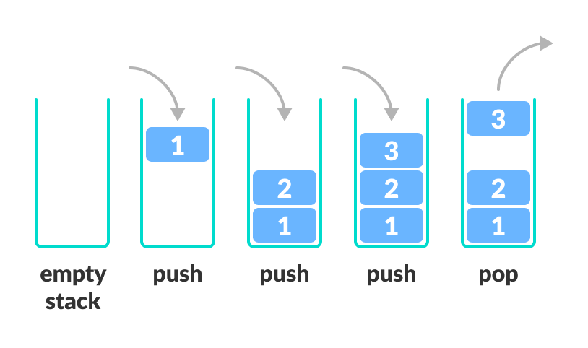
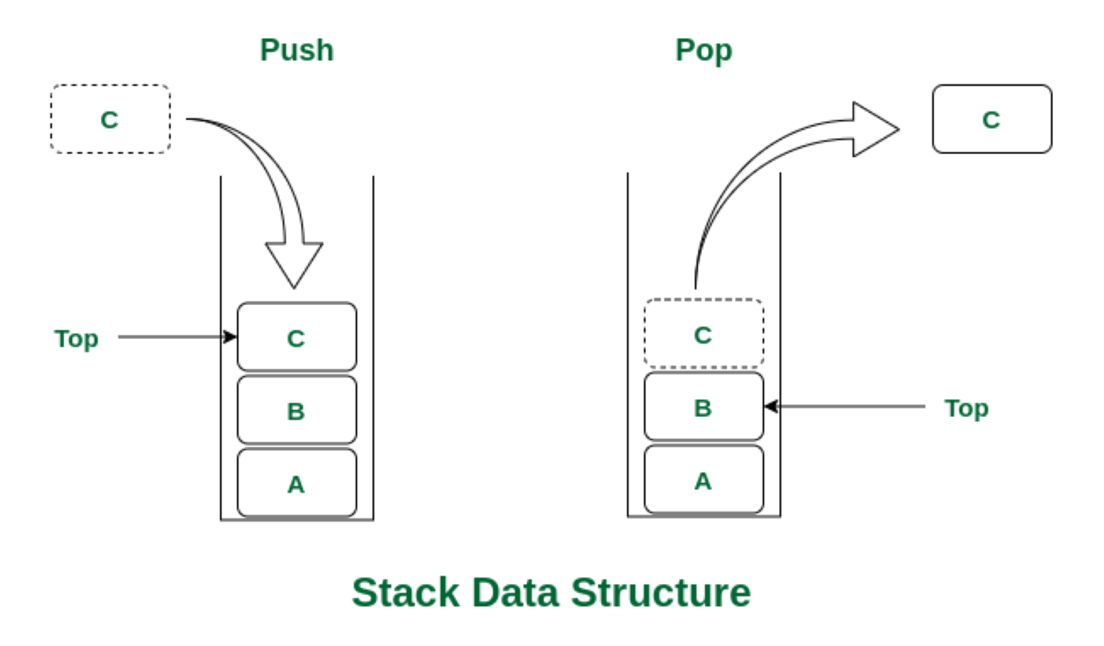
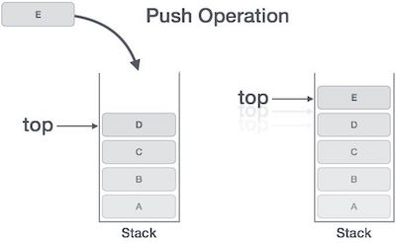
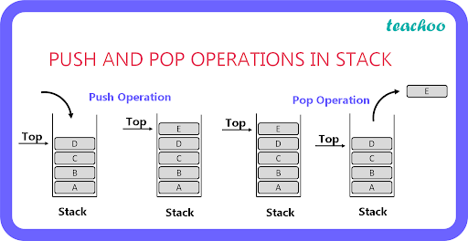

Stack Operations
Operation | Description
Push | Insert element
Pop | Remove element
Peek | View top element
isEmpty | Check stack

Stack Using Java Built-in Class
import java.util.Stack;

public class StackExample {

public static void main(String[] args) {

Stack<Integer> stack = new Stack<>();

stack.push(10);
stack.push(20);
stack.push(30);

System.out.println(stack.pop());
System.out.println(stack.peek());
}
}
Output:
30
20

Stack Implementation Using Array
class StackArray {

int top=-1;
int size=5;
int[] stack=new int[size];

void push(int x){
if(top==size-1){
System.out.println("Stack overflow");
} else{
stack[++top]=x;
}
}

int pop(){
if(top==-1){
System.out.println("Stack underflow");
return -1;
}
return stack[top--];
}
}

Lab Exercises (Stacks)
1️⃣ Implement stack using array
2️⃣ Reverse a string using stack
Example:
Input: HELLO
Output: OLLEH
3️⃣ Check balanced parentheses
Example:
Input: (a+b)*(c+d)
Output: Balanced
4️⃣ Convert infix expression to postfix
Example:
A+B → AB+

3. Queue
A queue follows FIFO (First In First Out).
Example:
Front → 10 20 30 40 ← Rear

Queue Structure
z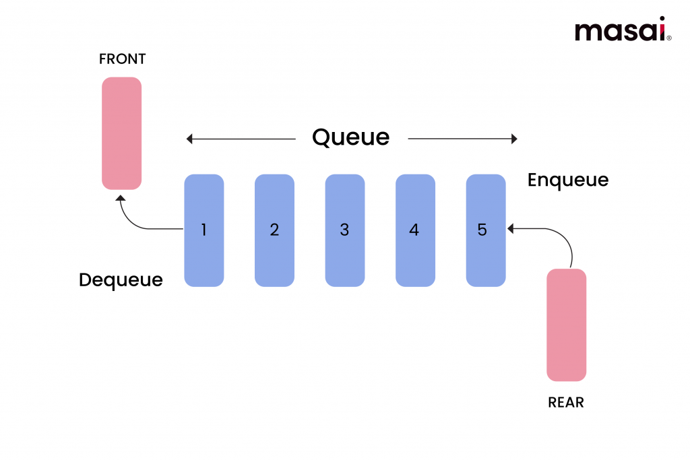
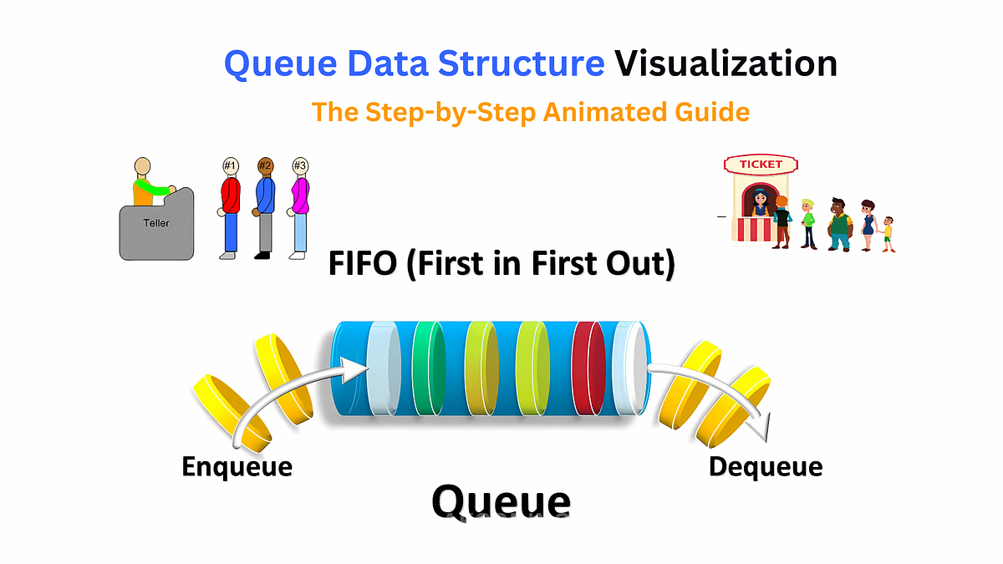

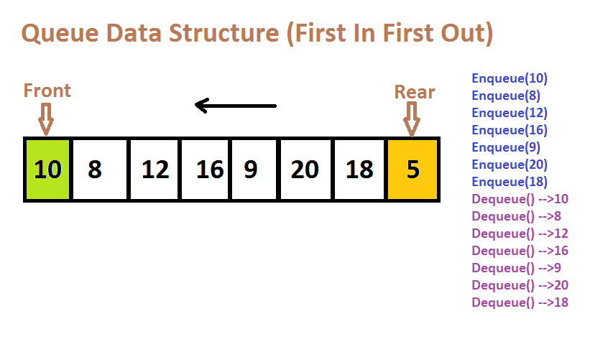

Queue Operations
Operation | Description
Enqueue | Insert element
Dequeue | Remove element
Peek | View front
isEmpty | Check empty

Queue Using Java
import java.util.LinkedList;
import java.util.Queue;

public class QueueExample {

public static void main(String[] args) {

Queue<Integer> queue = new LinkedList<>();

queue.add(10);
queue.add(20);
queue.add(30);

System.out.println(queue.remove());
System.out.println(queue.peek());
}
}
Output:
10
20

Queue Implementation Using Array
class QueueArray {

int front=0;
int rear=-1;
int size=5;
int[] queue=new int[size];

void enqueue(int x){
if(rear==size-1){
System.out.println("Queue full");
}
else{
queue[++rear]=x;
}
}

int dequeue(){
if(front>rear){
System.out.println("Queue empty");
return -1;
}
return queue[front++];
}
}

Lab Exercises (Queues)
1️⃣ Implement queue using array
2️⃣ Implement queue using linked list
3️⃣ Reverse a queue
Example:
Input: 10 20 30
Output: 30 20 10
4️⃣ Generate binary numbers using queue
Example:
Input: 5
Output:
1
10
11
100
101

Comparison: Array vs Stack vs Queue
Structure | Access | Use Case
Array | Random access | Storage
Stack | LIFO | Undo, recursion
Queue | FIFO | Scheduling

Real World Applications

Arrays
- Database indexing
- Matrix operations
- Image processing

Stacks
- Function call stack
- Expression evaluation
- Undo/Redo operations

Queues
- CPU scheduling
- Print queues
- Network packet buffering

Mini Lab Project
Build a Task Scheduler Simulation:
Requirements:
1️⃣ Queue stores tasks
Task1
Task2
Task3
2️⃣ Stack stores completed tasks
3️⃣ Array stores task history

Example output:
Running Task1
Running Task2
Undo Task2

